# LinkedIn Ad

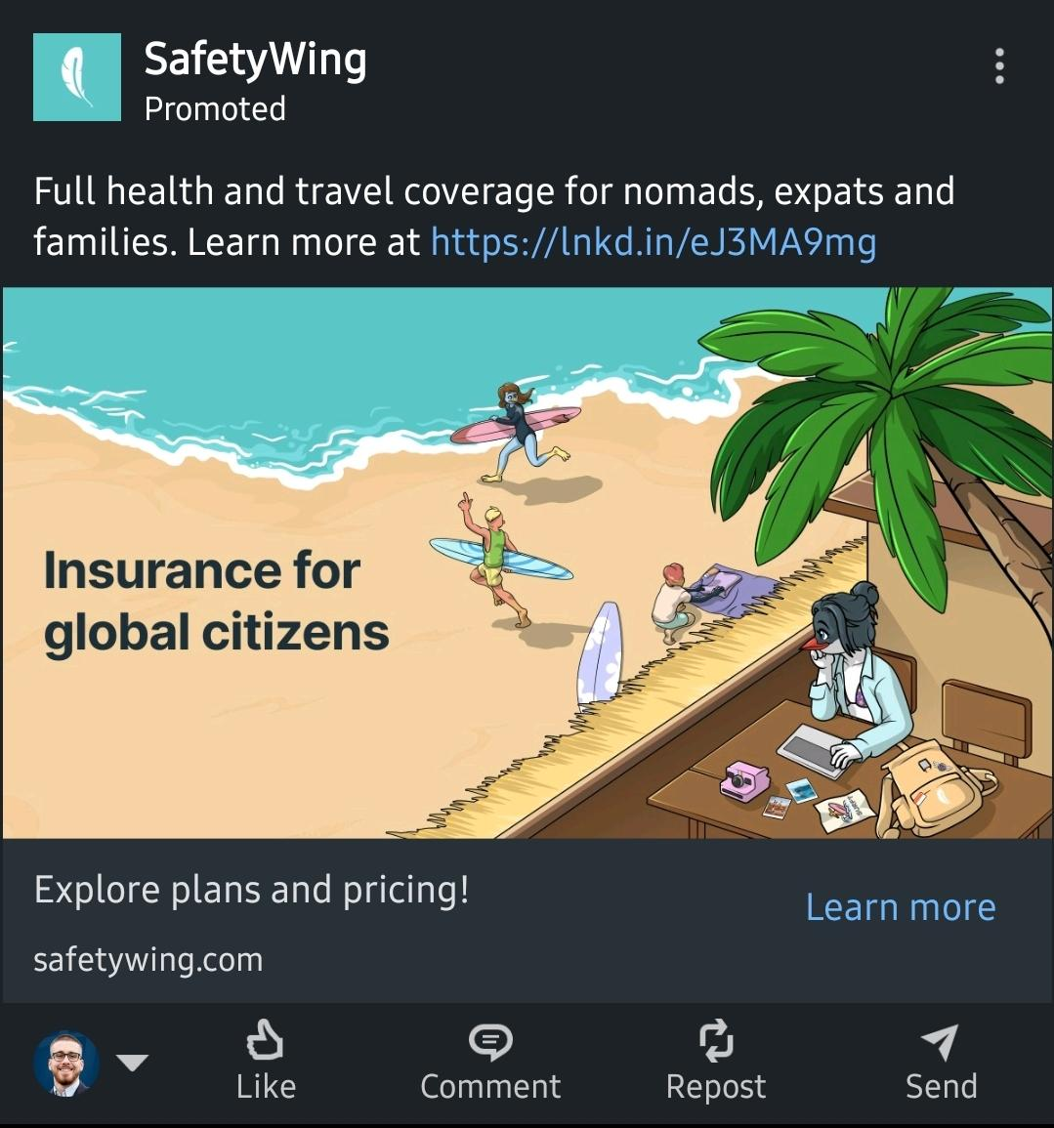

Being a digital nomad means chasing what’s next

But what if *next* doesn’t go as planned?

You booked the flight.  
Found the coworking space.  
Planned the visa run.

But you didn’t plan for…

- What if you slip on cobblestones in Lisbon?  
- What if you get food poisoning in Bali?  
- What if a fever makes you miss your flight in Medellín?

Bad experiences are never part of the itinerary.  
But they show up fast, and they cost more than money.

That’s why SafetyWing exists.  
Founded by digital nomads, for digital nomads.

We’re your invisible safety net in every timezone.  
Quietly protecting your freedom while you chase the next big thing.

We cover the *what-ifs* so you can focus on the *what’s next*.

**CTA: Cover the *what-ifs* before they happen.**  
**Visual Concept #1 – “The Vanishing Laptop”**

**Scene:** A beautiful café table in Chiang Mai. Half-finished coconut smoothie. An open laptop with Google Maps showing “Next Destination: Bali.”  
 But the **laptop is glitching or fading out**, as if disappearing.  
 Next to it, a phone shows: **“Emergency Room - Estimated Cost: $6,450”**

**Headline Overlay:**

“You planned the trip. You didn’t plan the *what if*.”  
 **What if your freedom disappears in an instant?**

**Why it works:**This mirrors *exactly* what digital nomads obsess over: **freedom, travel, tech, and cost** all collapsing in one frame.

Why I believe in the SafeyWing model (Charlie Munger):

* unique,
* expensive
* sticky
* air
* and managed by an individual with integrity and a long-term mindset.

Flappy Bird game trailer:

* Choose your avatar (digital nomad)
* Cyberpunk world
* SafetyWing net capturing

Remote team lead magnet - how to have a 97% employee retention rate with employees

Providing value on how to live remotely